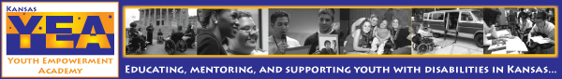
Kansas Youth Empowerment Academy Newsletter Issue #21 July 2013
So, July is almost over, and you know what that means? It means that we are right on the edge of school starting, but we are also still in summertime mode! We hope that you all have had an awesome summer and that you have filled your days with fun, food, friends, and a lots of sunshine! Maybe you are still planning some fun activities, like vacations, sports, barbecues, etc. If so, then you have to check out this newsletter. We have dedicated a portion of this issue to articles on enjoying summer activities like traveling, recreation, and camps. Because school is right around the corner, we also want to help prepare you for a new year. Whether you are still in high school or headed to college, read below for articles to help you prepare for each.

Since April, KYEA has been empowering youth full force! We have had many programs and fundraising efforts in the last few months. Things have been very busy around the office, and we want to update you on all of it. So, be sure to check out the many KYEA updates and photos in this issue.

Enjoy the rest of your summer! Now, read on...
- Carrie Greenwood, Program Coordinator

Please show your support for youth with disabilities by donating to KYEA today. You can donate directly by mail or by visiting our website. We hope you will enjoy the return of our newsletter, full of local updates, national news, and even more about the amazing things youth with disabilities are doing in Kansas.

in this issue

:: Accessibility in the
Netherlands: A Closer Look

:: KYEA Program Updates

:: State and National Opportunities

:: It's Back to School Time!

:: KYEA Fundraising

:: Seeking Newsletter Writers

:: Spotlight On Youth with Disabilities

:: Question of the Month

:: Helpful Websites
Accessibility in the Netherlands: A Closer Look
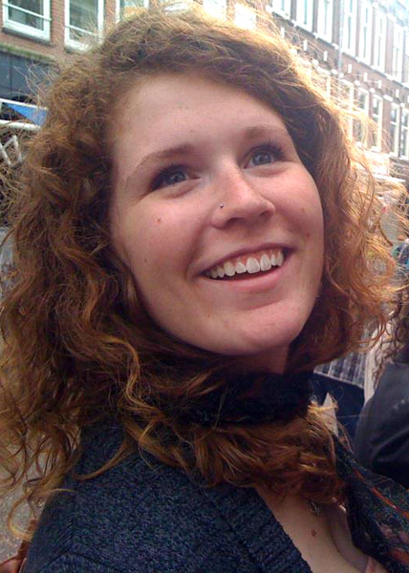
By Sydney Spyres, Outreach Coordinator

Since a portion of this newsletter is focused on summer traveling and new experiences, we thought we would take a closer look at accessibility in other countries. Read below for Sydney's experience while in the Netherlands last fall.

The Netherlands is well known for it's very liberal stance on many political issues. So, while living there, I was very surprised to find out how unethical they are when it comes to the equality of people with disabilities. It wasn't something I noticed right away; I was too busy with all the excitement and nervousness of acclimating myself to a new culture. When I had settled into my new life, I began to be able to take more of a critical look at the country and it's culture.

The old cities do not provide proper accessibility. For example, most streets are asphalt, but the historic city centers are almost always paved with bumpy cobblestones. The argument to keep these is that they add to the old, historic city feel people expect to see when they are in Europe. But the inequality goes beyond things like

Accessibility in the Netherlands (cont.)

the streets or not providing ramps to close the gaps between the train and the station platform. I did some research and found the Netherlands is far from treating everyone equally. There have been multiple reports of people with disabilities dying in institutions due to lack of proper care. Some people are being isolating and tied to restraints. I was disgusted to hear a country that prides itself in being so before-the-times is many political areas is still treating many of it's citizens as less than human.

If I had never started working at KYEA almost two years ago, it is fair to say I never would have noticed or been interested in researching these things. I have so many reasons to be thankful for KYEA. Looking back at where I was in my life two years ago, it's hard for me not to believe in fate or the idea that everything happens for a reason. I didn't know at the time of my interview how large of an impact this organization, and all the people involved, would have on my life. Thanks to KYEA, my outlook has been widened and developed in ways I didn't even know needed improvement. I am confident in the fact that this organization has, and will continue to, make me into a better social worker and individual in my every day life.

KYEA Updates  It has been a busy spring and summer at KYEA! We have had two full programs, lots of intern graduations, and many successful fundraising efforts. Read on to learn about recent KYEA successes! |  | KYEA Fundraising  Our recent successes and upcoming exciting fundraiser!  by Johnna Godinez and Julia Thomas  Annual Spring Fling Raises $1100 to Support Youth with Disabilities!  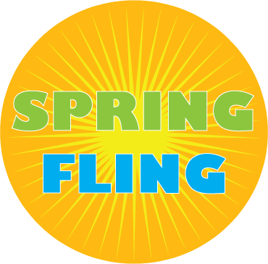  The second annual Spring Fling, a collaborative event between the Topeka office of the Resource Center for Independent Living, held this past April was a smashing success. KYEA raised around $1100 from the sale. All sale proceeds will go directly toward serving youth with disabilities. To our beloved donors and volunteers - YOU made us successful! Thanks for your partnership, service, and time. Visit www.kyea.org/springfling13 for more information.  KYEA Attends "Topeka Gives" Event  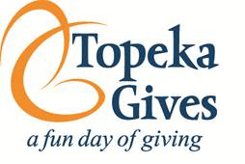  The Topeka Gives event was held June 19 at Fairlawn Plaza Mall in Topeka. It was an opportunity for individuals to make a donation to KYEA and where the Topeka Community Foundation made a financial match for each donation. This was a great experience where KYEA raised a little money and met and introduced our agency to many people for the first time from the Topeka community.  Buy Chiefs Tickets... Support KYEA!    KYEA is embarking on a new funding opportunity for all of you football fans! In partnership with the Kansas City Chiefs, KYEA is selling tickets to select home games for just $35.00! Our goal is to sell 10 tickets per game, which would give us a grand total of $500 profit going straight to supporting youth with disabilities through our organization. We have tickets for the following games:  August 29 - Chiefs vs. Packers  Request By: August 13  October 20 - Chiefs vs. Texas  Request By: October 4  October 27 - Chiefs vs. Browns  Request By: October 12  November 24 - Chiefs vs. Chargers  Request By: November 8  To order tickets or for more information, contact Julia at juliat@kyea.org.
Empower Me! Challenge

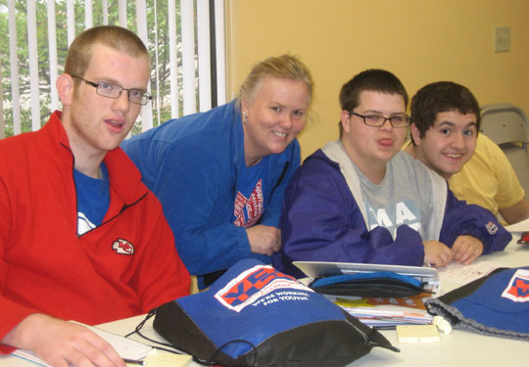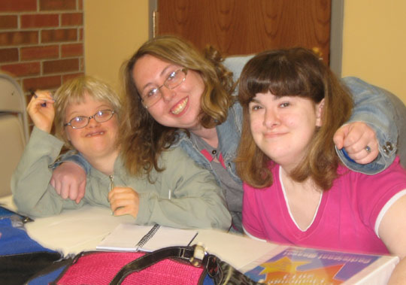

The 2013 Empower Me! Challenge was a great success! This year's EMC took place during the school day, and KYEA was able to partner with local high schools to have their students with disabilities experience three weeks of empowerment. This year's EMC took place on Monday, Wednesday, and Friday during three weeks in April. The youth participants came to our KYEA office and heard from speakers on various transition topics. They also worked on setting goals for the future, created a resume and experienced a mock job interview, learned about local resources, visited the Topeka Workforce Center and Washburn University, went shopping for a job interview outfit, and topped the three weeks off with a Mentor Lunch and graduation ceremony. Six youth from Washburn Rural High School and one youth from Highland Park High School participated in this year's EMC. All of the participants enjoyed fun moments, new friendships, and many learning experiences over the three weeks of the program!

2013 EMC Graduates-welcome to the KYEA family!
Thanks to the local high schools who partnered with us, as well as everyone who was a part of this year's EMC!

The 2013 EMC was made possible by a grant from the Topeka Community Foundation. Thanks to TCF for awarding us a new grant for 2014!
Kansas Youth Leadership Forum

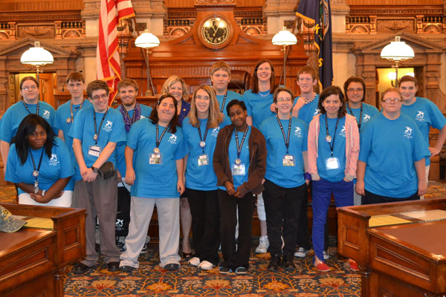

"I Can! I Will!" This is the theme that rang out during the 2013 Kansas Youth Leadership Forum. Sixteen youth leaders with disabilities from across the state gathered to learn about leadership, disability pride, advocacy, and so much more! All delegates left with specific goals for their future, as well as a new understanding of the possibilities for an empowered life. The 2013 KSYLF took place on June 10-15 at Washburn University in Topeka. In addition to the 16 youth delegates, 20 volunteers and staff members were present throughout the week, including 7 alumni. The delegates enjoyed hearing from various community speakers, including Lee Jones, motivational speaker and personal trainer from Kansas City, who provided the Mentor Luncheon keynote. The delegates also experienced the usual week highlights of wheelchair basketball and a barbecue, a Day at the Capital, Real Life Affair, talent show, dance, and more!
2013 KSYLF Graduates-welcome to the family!
Thanks to all of our volunteers, mentors, speakers, and sponsors!

For a full list of sponsors, visit www.kyea.org and click on the About Us>Funding page.
Seeking Newsletter Writers and Contributors!

Are you a youth with a disability who likes to write? We need you! KYEA is looking for young people who can help us out with our bi-monthly newsletter. We would like to get a few youth who can write some articles, do some interviews, or do a little research for future newsletter issues. If you have an interest in writing or journalism, or would like to help out with our newsletter, contact Carrie at carrieg@kyea.org.

Read on for more cool news and helpful articles!

Interns Creating Opportunities Now  Congratulations to all of our ICON interns who completed their five months of employment this spring!  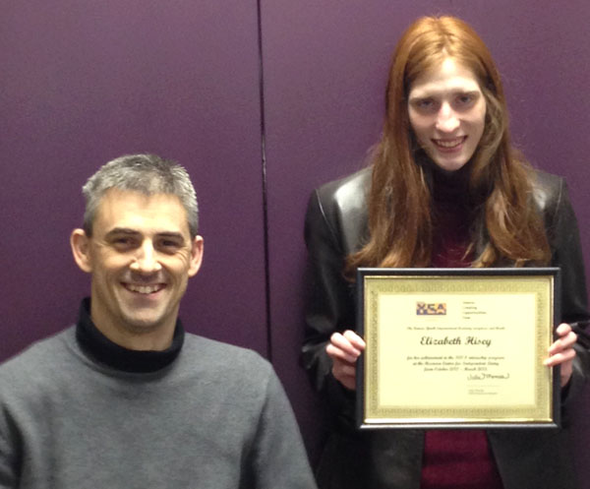  Elizabeth Hisey completed her internship at the Resource Center for Independent Living in Osage City in April. Way to go Lizzy!  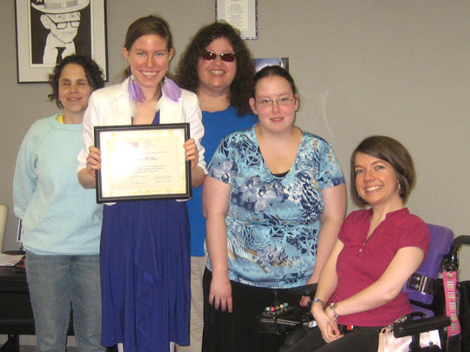  Allison Wilkes completed her internship at the KYEA office in June. Congrats Allison! |  | Spotlight on YWD!  Exciting news from youth with disabilities in our state...  Ashlee Johnston, KSYLF Alumna 2011  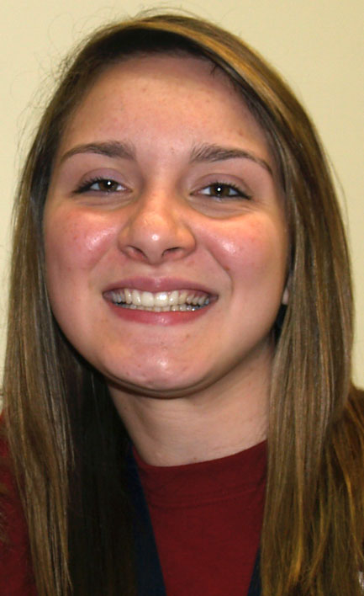  Ashlee will be taking part in a mission for the LDS Church very soon. She will be on this mission for 18 months. Once Ashlee returns, she plans to attend Brigham Young University in Rexburg, ID. Ashlee is taking charge of her life, and we are so proud!  Josh Ruoff, KSYLF Alumni 2011  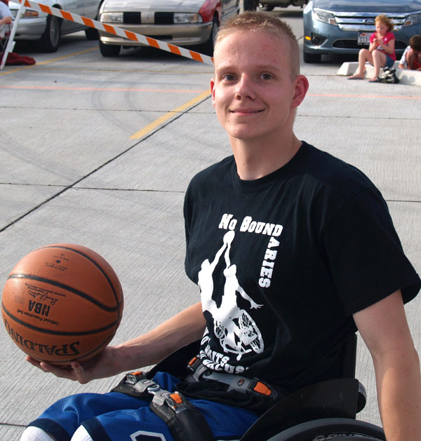  Josh has been playing wheelchair basketball for years, and now he will be sharing his talents on a bigger level! This coming year, Josh will be attending the University of Missouri to play wheelchair basketball and will major in broadcast journalism and public relations. Congrats on your achievements Josh!  More updates on next page…

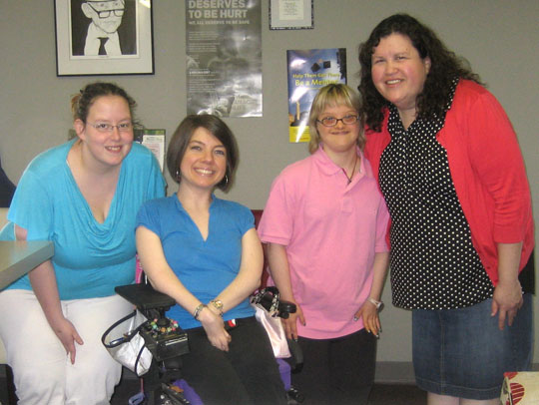  Allison Nichols completed her internship at the KYEA office in May. Way to go Allison!  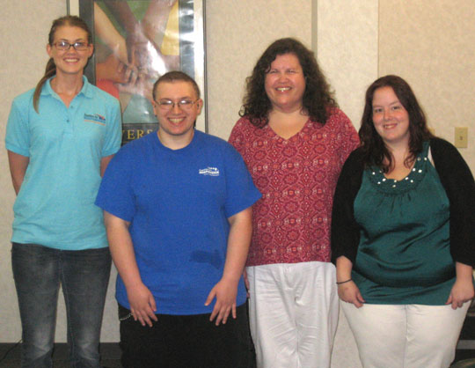  Marshall Hoffner completed his internship at the Coalition for Independence in Kansas City in May. Congrats Marshall! |  | 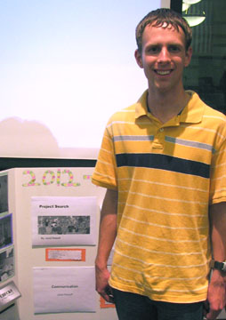  Jared Ratzlaff, KSYLF Alumni 2011  In the spring, Jared completed three rotations as an intern at the Newton Medical Center. Jared currently works at Dillons as a Courtesy Clerk and hopes to increase his hours and work in other departments this fall. He is also planning to explore taking a class at the Hutchinson Community College campus in Newton. Way to go Jared!
Question of the Month
What is your favorite thing to do in the summer?

Hanging out with my friends and family.

- Phaleesha Chronister, KSYLF Alumna '10

Swim!
- Dayna Rucker, KSYLF Alumna '09

Relax, drink a cold beverage, and enjoy the company of others.
- Brian Gano, KSYLF Alumni '04

Write fan fiction, hang with friends, watch shows on the web. And it means my birthday is coming closer.
- Katie Horrell, KSYLF Alumna '12

In between work, I love to go to the lake with family and fish, swim, and enjoy long summer nights.
- Jessica Calderon (Bosley), KSYLF Alumna '12
News and Events

Opportunities in Kansas

- Take advantage of this leadership opportunity! The Governor's office has extended their deadline for fall internship applications. College and graduate students- get hands on experience working in state government. Read more at https://governor.ks.gov/serving-kansans/governor's-office-internship-program.

- Do you want to make a difference for people with disabilities in Kansas? Be a part of the Grassroots Advocacy Network and learn how to advocate! Read more at http://kansasmentalhealthcoalition.onefireplace.com.  Opportunities on a National Level  - The U.S. recently celebrated the 23rd anniversary of the Americans with Disabilities Act. Read what President Obama had to say about advancing the goals of the ADA. View the proclamation at www.whitehouse.gov/the-press-office/2013/07/25/proclamation-anniversary-americans-disabilities-act-2013.  - COOL WEBSITE! Everybody: An Artifact History of Disability in America- a new online exhibit that takes visitors through the history of people with disabilities. Read more at http://everybody.si.edu.  - Assistive technology can be a huge help to living independently. Check out some real world examples of youth using assistive technology through these "AT in Action" videos at www.pacer.org/stc/videos.  - Do you want to learn more about being included in mainstream college athletic programs? The "Athletic Opportunities for Students with Disabilities: Focus on Colleges and Universities" webinar will talk about including students with disabilities in these programs, as well as creating adapted programs. Read more at www.ada-audio.org/Schedule (scroll to Aug. 20 webinar) |  |  |  | Going to young single adult conferences.  - Allison Wilkes, ICON Alumna  Sleep!!!!!!!!!  - Christian Roberson, KSYLF Alumni '08  Enjoy the beautiful weather and go to college classes.  - Joe Stroud, KSYLF Alumni '07  Enjoy my wonderful son, try to get the word out for the upcoming KSYLF, and help people with disabilities. My 3 year old loves to help people too with all kinds of disabilities.  - Callie Hargett, KSYLF Alumna '05  I go for walks, do things in the house, work, knit, read books, write, and watch old movies and TV shows.    - Rochelle Kinney, KSYLF Alumni '05  Running, Running!  - Billy Clark, KSYLF Alumni '13

Helpful Websites
Have you taken a vacation this summer? Do you have a trip coming up? Vacations can be a ton of fun! For people with disabilities, though, there is oftentimes some extra planning involved. You have to make sure that your destination is accessible. This month, we have compiled a list of great sites that help you plan for a fully accessible summer... vacations, recreation, summer camps, and all!

compiled by Allison Wilkes and Carrie Greenwood

Society for Accessible Travel and Hospitality
http://sath.org
Website of a nonprofit organization that works to raise awareness of the needs of ALL travelers with disabilities, as well as promote access and expand travel opportunities in the United States and abroad.
It's Back to School Time!

Helpful Articles for Heading Back to the Classroom

It's almost time to head back to school! Where has summer gone? Whether you are going to be in high school this year or headed to college, we want to provide you with some helpful tips on how to make the most of your school year and advocate for yourself. And we're going to the experts for the info... two national organizations for youth with disabilities. Read their articles on the next page.
Advocating for Yourself in Middle School and High School: How To Get What You Need  from National Kids As Self Advocates-- www.fvkasa.org  You should always be able to have the accommodations you need in school for your disability or health care needs. Sometimes it just takes some extra effort to get what you need. Just because you have a disability it doesn't mean you can't do as well as the other kids in school, you have the same rights to succeed. By law every school has a process [a set way] for you to talk to teachers and others about what you need. Sometimes this plan or process is called an Individual Education Plan [IEP], a 504 plan, or sometimes something else.  Step 1: Evaluate what you need.  Step 2: Find a helpful resource at school.  Step 3: Talk to your teachers.  Step 4: Have a follow up meeting.  Read the full article at http://fvkasa.org/resources/files/ed-advocating-hsms.php.  Taking the Next Step: Life After High School  from the National Youth Leadership Network-- www.nyln.org  It can be difficult to decide what you are going to do after high school. It may also be scary. You may not know how to find out about your options. Remember that you can always ask the adults in your life for help. Your teachers, school counselors, and vocational rehabilitation counselors are all there to help. Older friends and family members who have already graduated may also be able to offer advice from their experiences.  Read the full article at www.nyln.org/wp-content/uploads/2010/10/NYLN-Education-Resource.pdf. |  |  | Able to Travel  www.abletotravel.org  Manages accessible business travel for people who are wheelchair mobile and use other mobility devices. They provide tours, cruises, safaris and rent out equipment that is needed. They also provide travel tips for your journey.  Access-Able Travel Source- Summer Adaptive Sports  http://access-able.com/summer_fun.cfm  Provides lots of links to accessible beaches, trails, and parks, as well as various adaptive recreation opportunities.  Accessible Travel Resources for the Blind  http://myblindspot.org/resources/marco-polo-travel-resources  Lots of helpful information and links for travelers with visual disabilities.  Deaf and Hard of Hearing Travel Ideas  http://gimponthego.com/tips9.htm  Provides lots of helpful information, things to think about, and tips for travelers who are deaf or hard of hearing.  Accessible Disability Travel  www.disabled-world.com/travel  Provides reviews of accessible tours, vacations and cruises for people with disabilities. They have reviews and articles about places to visit around the world.  Accessible.Travel  http://accessible.travel  This site provides accessible hotel reservations and services for people with disabilities in different countries.  Disability Travel and Recreation Resources  www.makoa.org/travel.htm  Provides an extensive list of accessible travel, recreation, and summer camp websites.
Thanks for reading our newsletter this month! Don't forget to donate by going to our website at www.kyea.org and check us out on Facebook (www.facebook.com/kansasyea) and Twitter (www.twitter.com/kansasyea)!
Let us know what you think about our newsletter! If there is anything that we can do to make our newsletter more accessible to you, please call us at 785-215-6655 so we can make the change for next time.
Sincerely, Carrie Greenwood, Kansas Youth Empowerment Academy

